*Florida International University*

*School of Computing and Information Sciences*

CIS 4911 - Senior Capstone Project

Software Engineering Focus

Feature Document

User Story #**666**

**Team Member:**

Andrew Mitchell

**Product Owner(s)**:

Francisco R. Ortega

**Mentor(s)**:

Francisco R. Ortega

...

**Instructor**: Masoud Sadjadi

**User Story** Implement Leap Shape Drawing

* As a User I would like to draw shapes with the leap motion so I can have another complete drawing medium.

Acceptance Criteria

* Be able to draw using all current multitouch draw functionality with the leap. (Alpha coloring, shape changes, etc).

**Use Case** #**666 – Leap Draw**

Use Case

Enable drawing shapes with the leap motion.

Details:

Actor: User

Pre-conditions:

Multitouch must be running.

Must hit the ‘symmetry line’ button.

Description:

Use case begins when the user enters the draw zone on the leap motion. The green dot disappears and the user begins to draw depending on their shape. The use case ends when the user leaves the drawing zone and enters the hover zone.

Post-conditions:

All drawings must be saved to the appropriate layers upon leaving the drawing zone.

Decision Support:

Frequency: Often. It is a fun tool that showcases the powers of the leap motion device. Core to our application if you lack a touch screen!

Criticality: High. It is a core feature. When testing how these devices function and how users will use them in the future, we want to see how they can do ‘precision work’ with the leap motion.

Risk: Low. A lot of testing to ensure active drawings are kept up to date properly, otherwise it is fairly simple.

Reliability: Highly.

Mean time to Failure – Almost never. It should only ‘fail’ when the user cannot find the draw zone or the leap motion is OFF.

Availability –Available when leap draw is enabled and the leap motion is plugged in and working.

Performance:

Lines should still lag with multiple fingers, circles, squares, and triangles should be very quick.

Supportability:

Leap motion device

Modification History:

Owner: Andrew Mitchell

Initiation date: 3/21/2016

Date last modified: 3/21/2016

**Use Case Diagram**

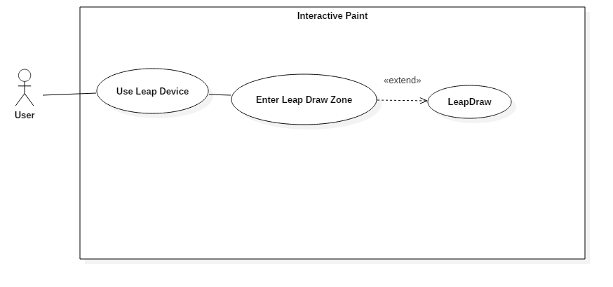

**Sequence Diagram**

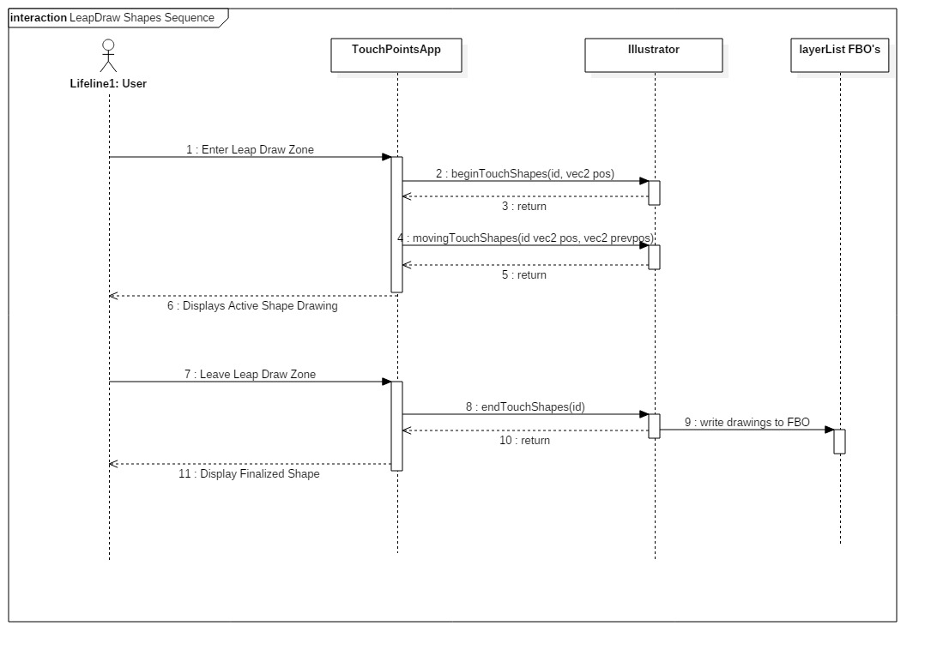

**Class Diagram**

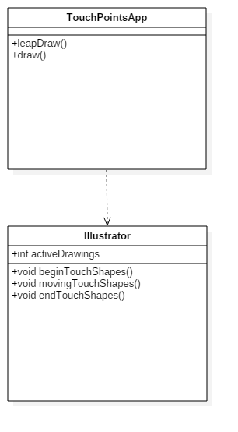

**Unit Test**

Sunny Day:

Test Case: Line Draw

Test Purpose:

Ensure the leap motion can draw with lines

Test Setup

1. Ensure the leap motion is on and leap draw is enabled (currently on by default)
2. Change to line draw mode
3. Move hand into the ‘draw’ zone to attempt to draw. (Move towards the screen until green circles vanish).
4. Remove hand from draw zone

Test Output:

Lines began to draw on the screen once the green circles disappeared.

Expected Output:

Lines should begin drawing where the green circle disappeared from.

Test Case: Leap Circle Draw

Test Purpose:

Make sure the leap can draw circle shapes.

Test Setup

1. Ensure the leap motion is on and leap draw is enabled (currently on by default)
2. Change to circle draw mode.
3. Move hand into the ‘draw’ zone to attempt to draw. (Move towards the screen until green circles vanish).
4. Remove hand from draw zone

Test Output:

Began a circle that changed size while finger was moving inside the draw zone. When exiting the draw zone the circle stayed that size.

Expected Output:

A circle should appear when entering the draw zone. Moving your finger should change the radius.

Leaving the draw zone should save that circle to the canvas.

Test Case: Leap Draw Rectangle Shapes

Test Purpose:

Ensure the leap motion can draw rectangles.

Test Setup

1. Ensure the leap motion is on and leap draw is enabled (currently on by default)
2. Change to rectangle draw mode
3. Move hand into the ‘draw’ zone to attempt to draw. (Move towards the screen until green circles vanish).
4. Remove hand from draw zone

Test Output:

Rectangle appeared when the draw zone was entered. Moving my fingers changed their sizes.

Leaving the draw zone drew the rectangles to the canvas (they persisted).

Expected Output:

Rectangles should appear when entering the draw zone. It should change size based on the fingers movement in the draw zone.

Leaving the draw zone should save that rectangle to the canvas.

Test Case: Leap Triangle Draw

Test Purpose:

Ensure the leap motion can draw the triangle shapes.

Test Setup

1. Ensure the leap motion is on and leap draw is enabled (currently on by default)
2. Change to triangle draw mode
3. Move hand into the ‘draw’ zone to attempt to draw. (Move towards the screen until green circles vanish).
4. Remove hand from draw zone

Test Output:

Triangles appeared when entering the draw zone. Moving my finger changed the width and height of the triangle.

Leaving the draw zone made the triangle stop moving and save to the canvas.

Expected Output:

Triangles should appear once the fingers enter the draw zone. Moving the fingers should change the triangles height and width.

Leaving the draw zone should save the triangle.

Rainy Day Tests:

Test Case: Sporadic Leap Motion Use

Test Purpose:

Make sure you can still change shapes and colors etc. After drawing with the leap and rapidly exiting the leap motion device. (Ensure activeDrawings = 0)

Test Setup

1. Make sure the leap motion is on and leap draw is available.
2. Rapidly move your hand around the leap motion device.
3. Perform long ‘stab’ motions with your hand over the leap motion device as well as sideways movements so it draws briefly and then exits the leap motions field of vision.
4. Change shape
5. Change Color
6. Draw your new shape and color

Test Output:

Successfully changed to a circle shape

Successfully changed to color teal.

Successfully drew a teal circle.

Expected Output:

You should be able to change the shape as well as the color. Drawing should continue to work afterwards.

**Integration Test**

Leap drawing currently works with all of our shapes.

It works with filled shapes as well as unfilled shapes.

Works with the eraser as well as any color variation you want, including alpha coloring.

Works with the symmetry functionality.

Correctly draws on the proper active layer as well.

**User Guide**

Leap drawing may take some getting used to. Hover your hand over the leap motion to where you can see Green circles with a tan outline as pictured below:

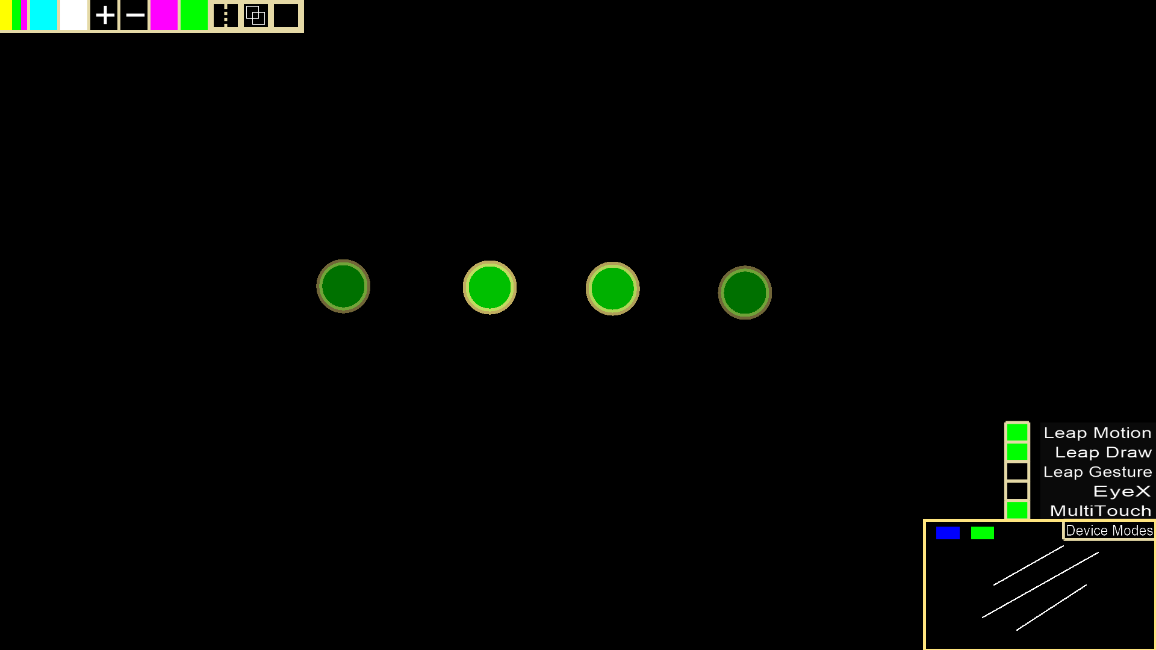

If you move forward with your fingers, the green circles will disappear, indicating you have enter the ‘draw’ zone.

A fairly simple way to draw with the leap seems to be with your thumb. If you perform a thumbs up gesture and turn your hand so your thumb is horizontal, then move your fist over the leap device until you see a single green dot appear. Then move your thumb forward to draw with a single finger.

Entering the draw zone with line mode enabled begins drawing a line at the location where your finger entered the draw zone. Moving your finger will draw a line wherever your hand moves. Exiting the draw zone will end the line.

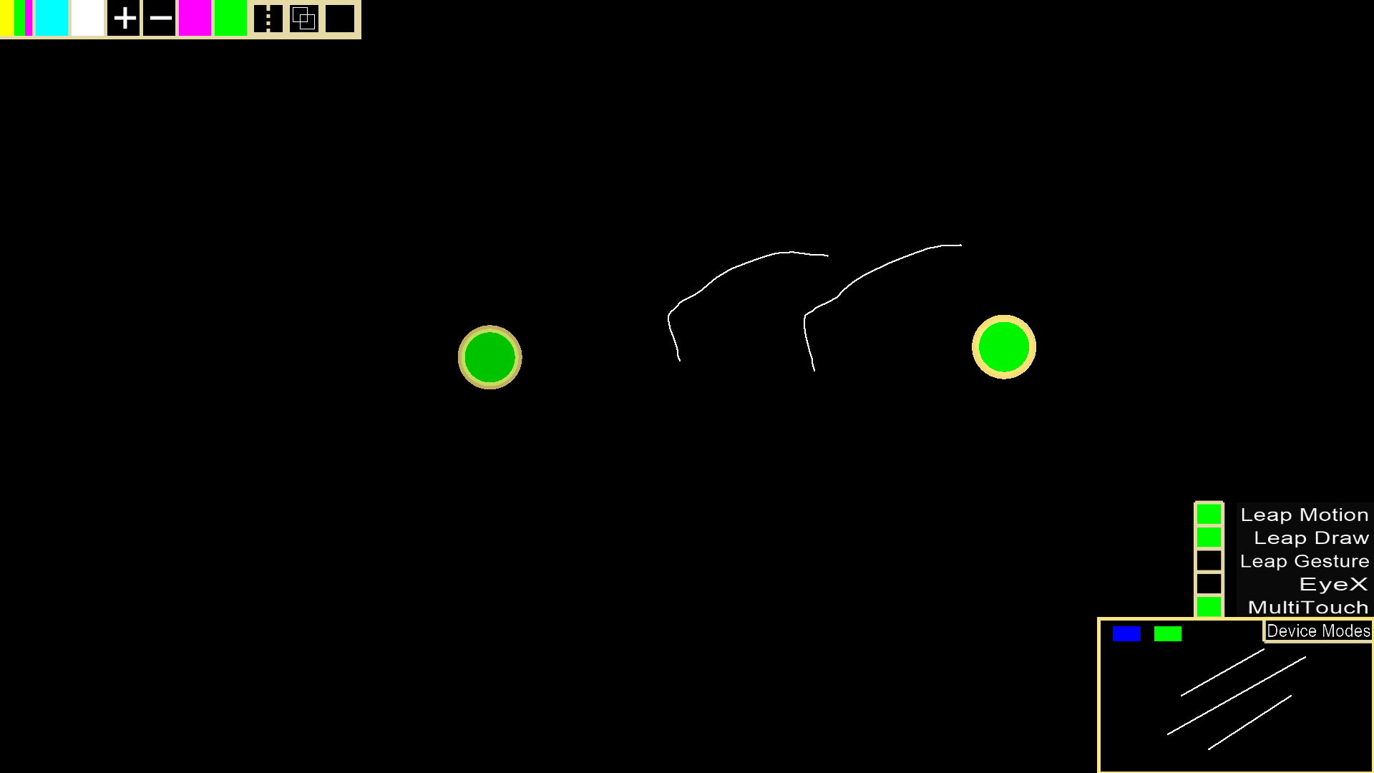

When entering the draw zone in circle mode, a circle will be created with a center at the location you entered the draw zone. Move your finger away from that location to increase its radius.

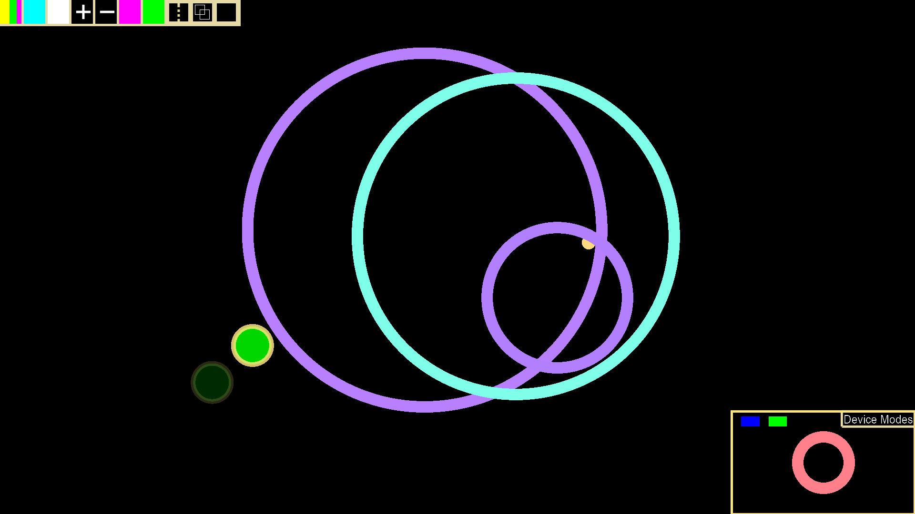

When entering the draw zone with rectangle shapes, a rectangle will be drawn with the location of your entrance as one corner, and the opposite corner being the location when exiting the draw zone.

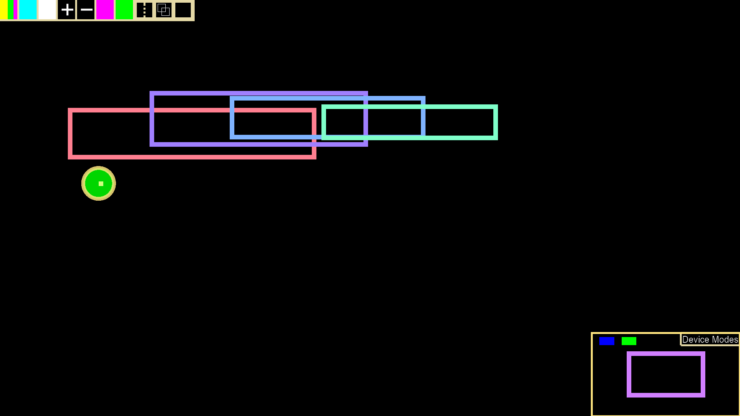

When entering the draw zone with a triangle shape the center of the base will be the location you entered the draw zone. The height will be determined by the change in height position of your finger, while the width of the triangle will be determined by the change in horizontal position of your finger.

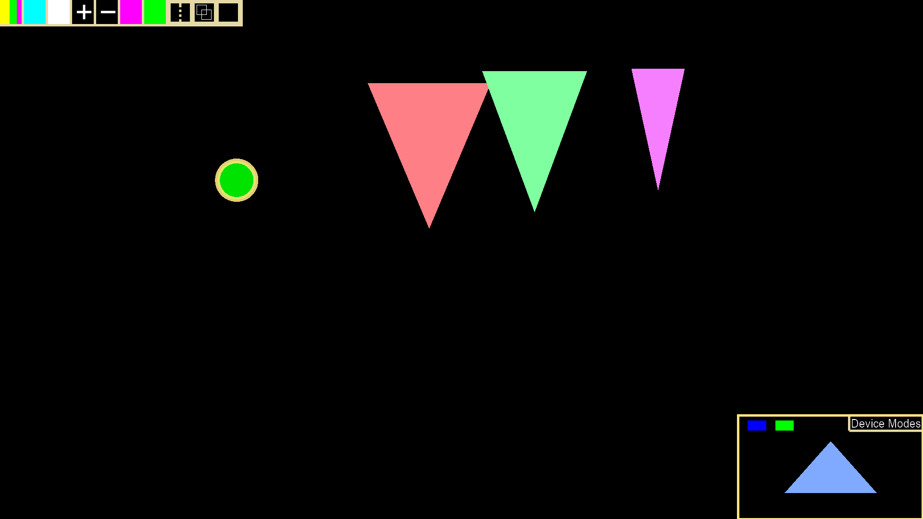

**Glossary**

Leap Draw – Drawing that occurs with the leap motion